**Lexar® JumpDrive® S47 USB 3.2 Gen 1 Flash Drive**

128GB

64GB

[Where to buy](https://americas.lexar.com/product/lexar-jumpdrive-s47-usb-3-2-flash-drive/)

**Key Features:**

**Up to 250MB/s read**

* USB 3.2 Performance
* Low-profile Design
* 256-bit AES Encryption
* Compatible

**Key Features:**

**Up to 250MB/s read**

* USB 3.2 Performance
* Low-profile Design
* 256-bit AES Encryption
* Compatible

[Features](https://americas.lexar.com/product/lexar-jumpdrive-s47-usb-3-2-flash-drive/#feature-section)[Specifications](https://americas.lexar.com/product/lexar-jumpdrive-s47-usb-3-2-flash-drive/#specifications)[Part Numbers](https://americas.lexar.com/product/lexar-jumpdrive-s47-usb-3-2-flash-drive/#product-numbers)[Related products](https://americas.lexar.com/product/lexar-jumpdrive-s47-usb-3-2-flash-drive/#related-products)

**Features**

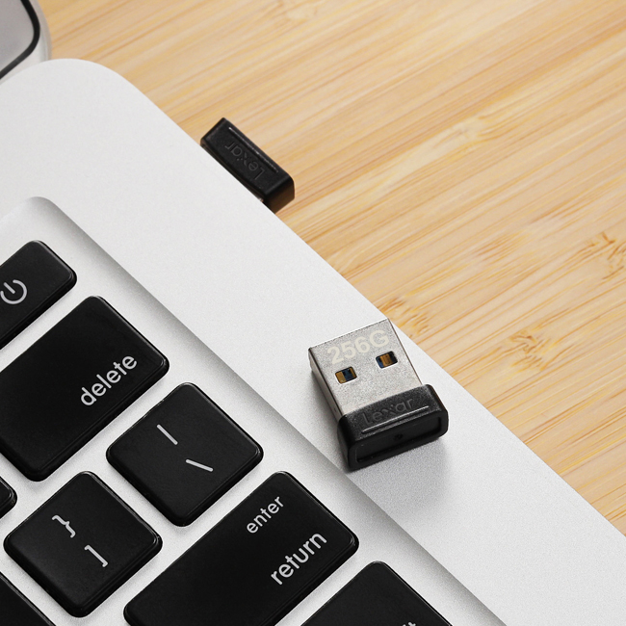

**Powerful performance in a compact design**

Get blazing fast speeds with Lexar® JumpDrive® S47 USB 3.2 Gen 1 Flash Drive. Store and transfer photos, videos, and files at USB 3.2 speeds—up to 250MB/s read1. Available in different capacity options to suit your needs.

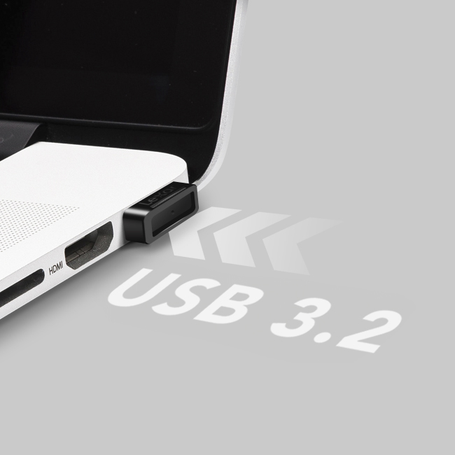

**Store and transfer content at USB 3.2 speeds**

Who wants to spend extra time waiting for files to transfer? With fast USB 3.2 Gen 1 performance, JumpDrive S47 provides speeds up to 250MB/s read1. And for added versatility, the drive is backwards compatible with USB 3.0 and 2.0 devices.

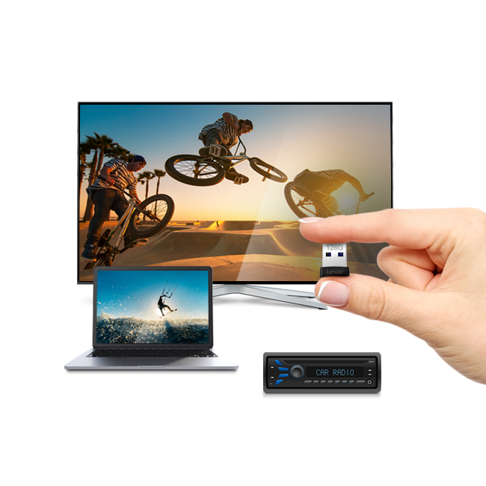

**Compact, portable, convenient**

This super convenient flash drive gives you powerful performance in a low-profile design, making it easy to use for TV’s, gaming, laptops and more with its simple plug-and-stay ability.

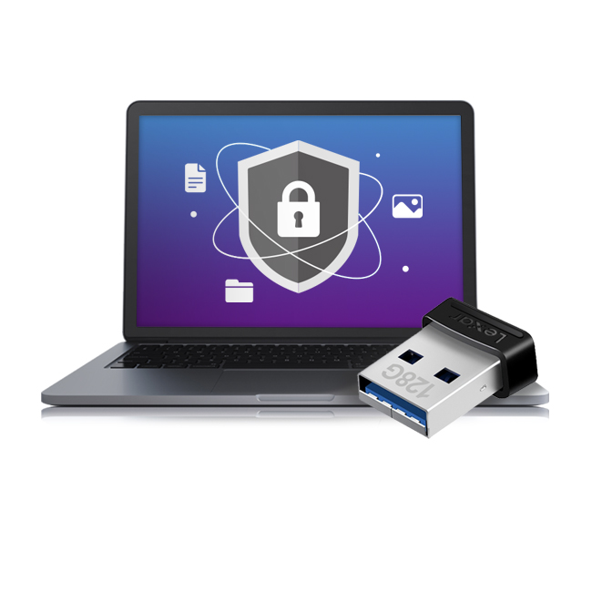

**Securely protect your files**

JumpDrive S47 includes an advanced security solution with 256-bit AES encryption to help protect your essential files against corruption, loss, and deletion. Easily create a password-protected vault that automatically encrypts data. And for peace of mind, files that are deleted from the vault are securely erased and can’t be recovered.



**Capacities to store all your data**

JumpDrive S47 comes in a wide range of capacities— 32/64/128/256GB. These options make it easy to find one to suit your needs and store more of your data in one place.



**Rigorously Tested**

JumpDrive S47 comes in a wide range of capacities— 32/64/128/256GB. These options make it easy to find one to suit your needs and store more of your data in one place.

**Specifications**

* Capacity

128GB | 64GB

* Performance

up to 250MB/s read1

* Interface

USB 3.2 Gen 1

* Operating Temperature

0 °C to 60 °C (32 °F to 140 °F)

* Storage Temperature

-20 °C to 85 °C (-4° F to 185 °F)

* Dimension (L x W x H)

17.33 x 14.95 x 7.45 mm / 0.68" x 0.58" x 0.29"

* Weight

2.12g / 0.0046 lbs (USB Only)

* Warranty

3 year limited warranty

* Compatibility

PC and Mac® systems